**Dependency Injection**

1. A screenshot of a cell phone
   
   Description automatically generated
2. In basically means that we request for an object, and behind the scenes Spring will create the object add all of its dependencies without even letting you know.
3. Dependency is the same thing as helper objects

**Injection Types**

1. Constructor Injection
2. Setter Injection
3. “Auto-wiring”

**Development Process – Constructor Injection**

1. Define the dependency interface and class
2. Create a constructor in your class for injection
3. Configure the dependency injection in Spring config file

**Define the dependency interface and class**

1. A screenshot of a social media post
   
   Description automatically generated

**Create a constructor in your class for injections**

1. A screenshot of a cell phone
   
   Description automatically generated

**Configure the dependency injection in Spring config file**

1. A screenshot of a cell phone
   
   Description automatically generated
2. Here the first bean is the definition of the dependency or the helper class and the second bean is the injection of the dependency where we include <contructor-arg>

**Behind the scenes of dependency Injection**

1. A screenshot of a social media post
   
   Description automatically generated

**Exercise Define dependency interface and class:**

1. Create an interface and name it “FortuneService”
2. Add public String getFortune() method in the interface
3. Create a class named as HappyFortuneServices
4. In its interfaces section add the interface.
5. Return “Today is your lucky Day!” in the getFortune method
6. Add public String getDailyFortune() method to the coach interface.

**Exercise Create a constructor in your class for injections:**

1. Define a private field “FortuneService fortuneService” in Baseball coach
2. Define a constructor in Baseball coach with the private field as the argument.
3. Use the this operator inside the constructor
4. Return fortuneService.getFortune() in the getDailyFortune method

**Exercise Configure the dependency injection in Spring config file**

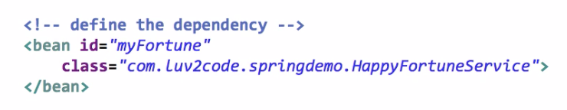

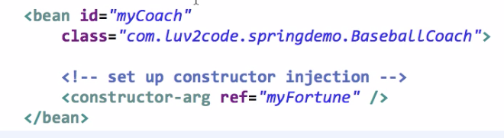

**Exercise:**

1. Add System.out.println(theCoach.getDailyFortune()); in the main HelloSpring class.
2. Add fortuneSerice to the trackCoach

**Setter Injections:** Spring will inject dependencies using setters.

**Development Process – Setter Injection**

1. Create setter methods in your class for injections
2. Configure the dependency injection in Spring config file

**Creating setter methods for injections**

A screenshot of a cell phone


**Configuring the dependency injection in the config file**

A screenshot of a cell phone


1. The property field is the Setter injection.
2. Spring will look for getFortuneService method

A screenshot of a cell phone


A screenshot of a social media post


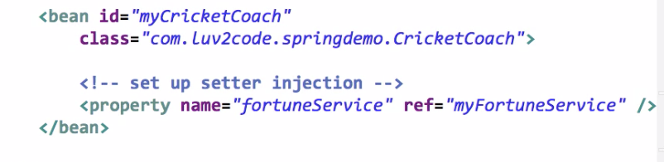

**Injecting Values from A properties file:**

**Development Process**

1. Create Properties File
2. Load Properties File in Spring config file
3. Reference value from Properties File